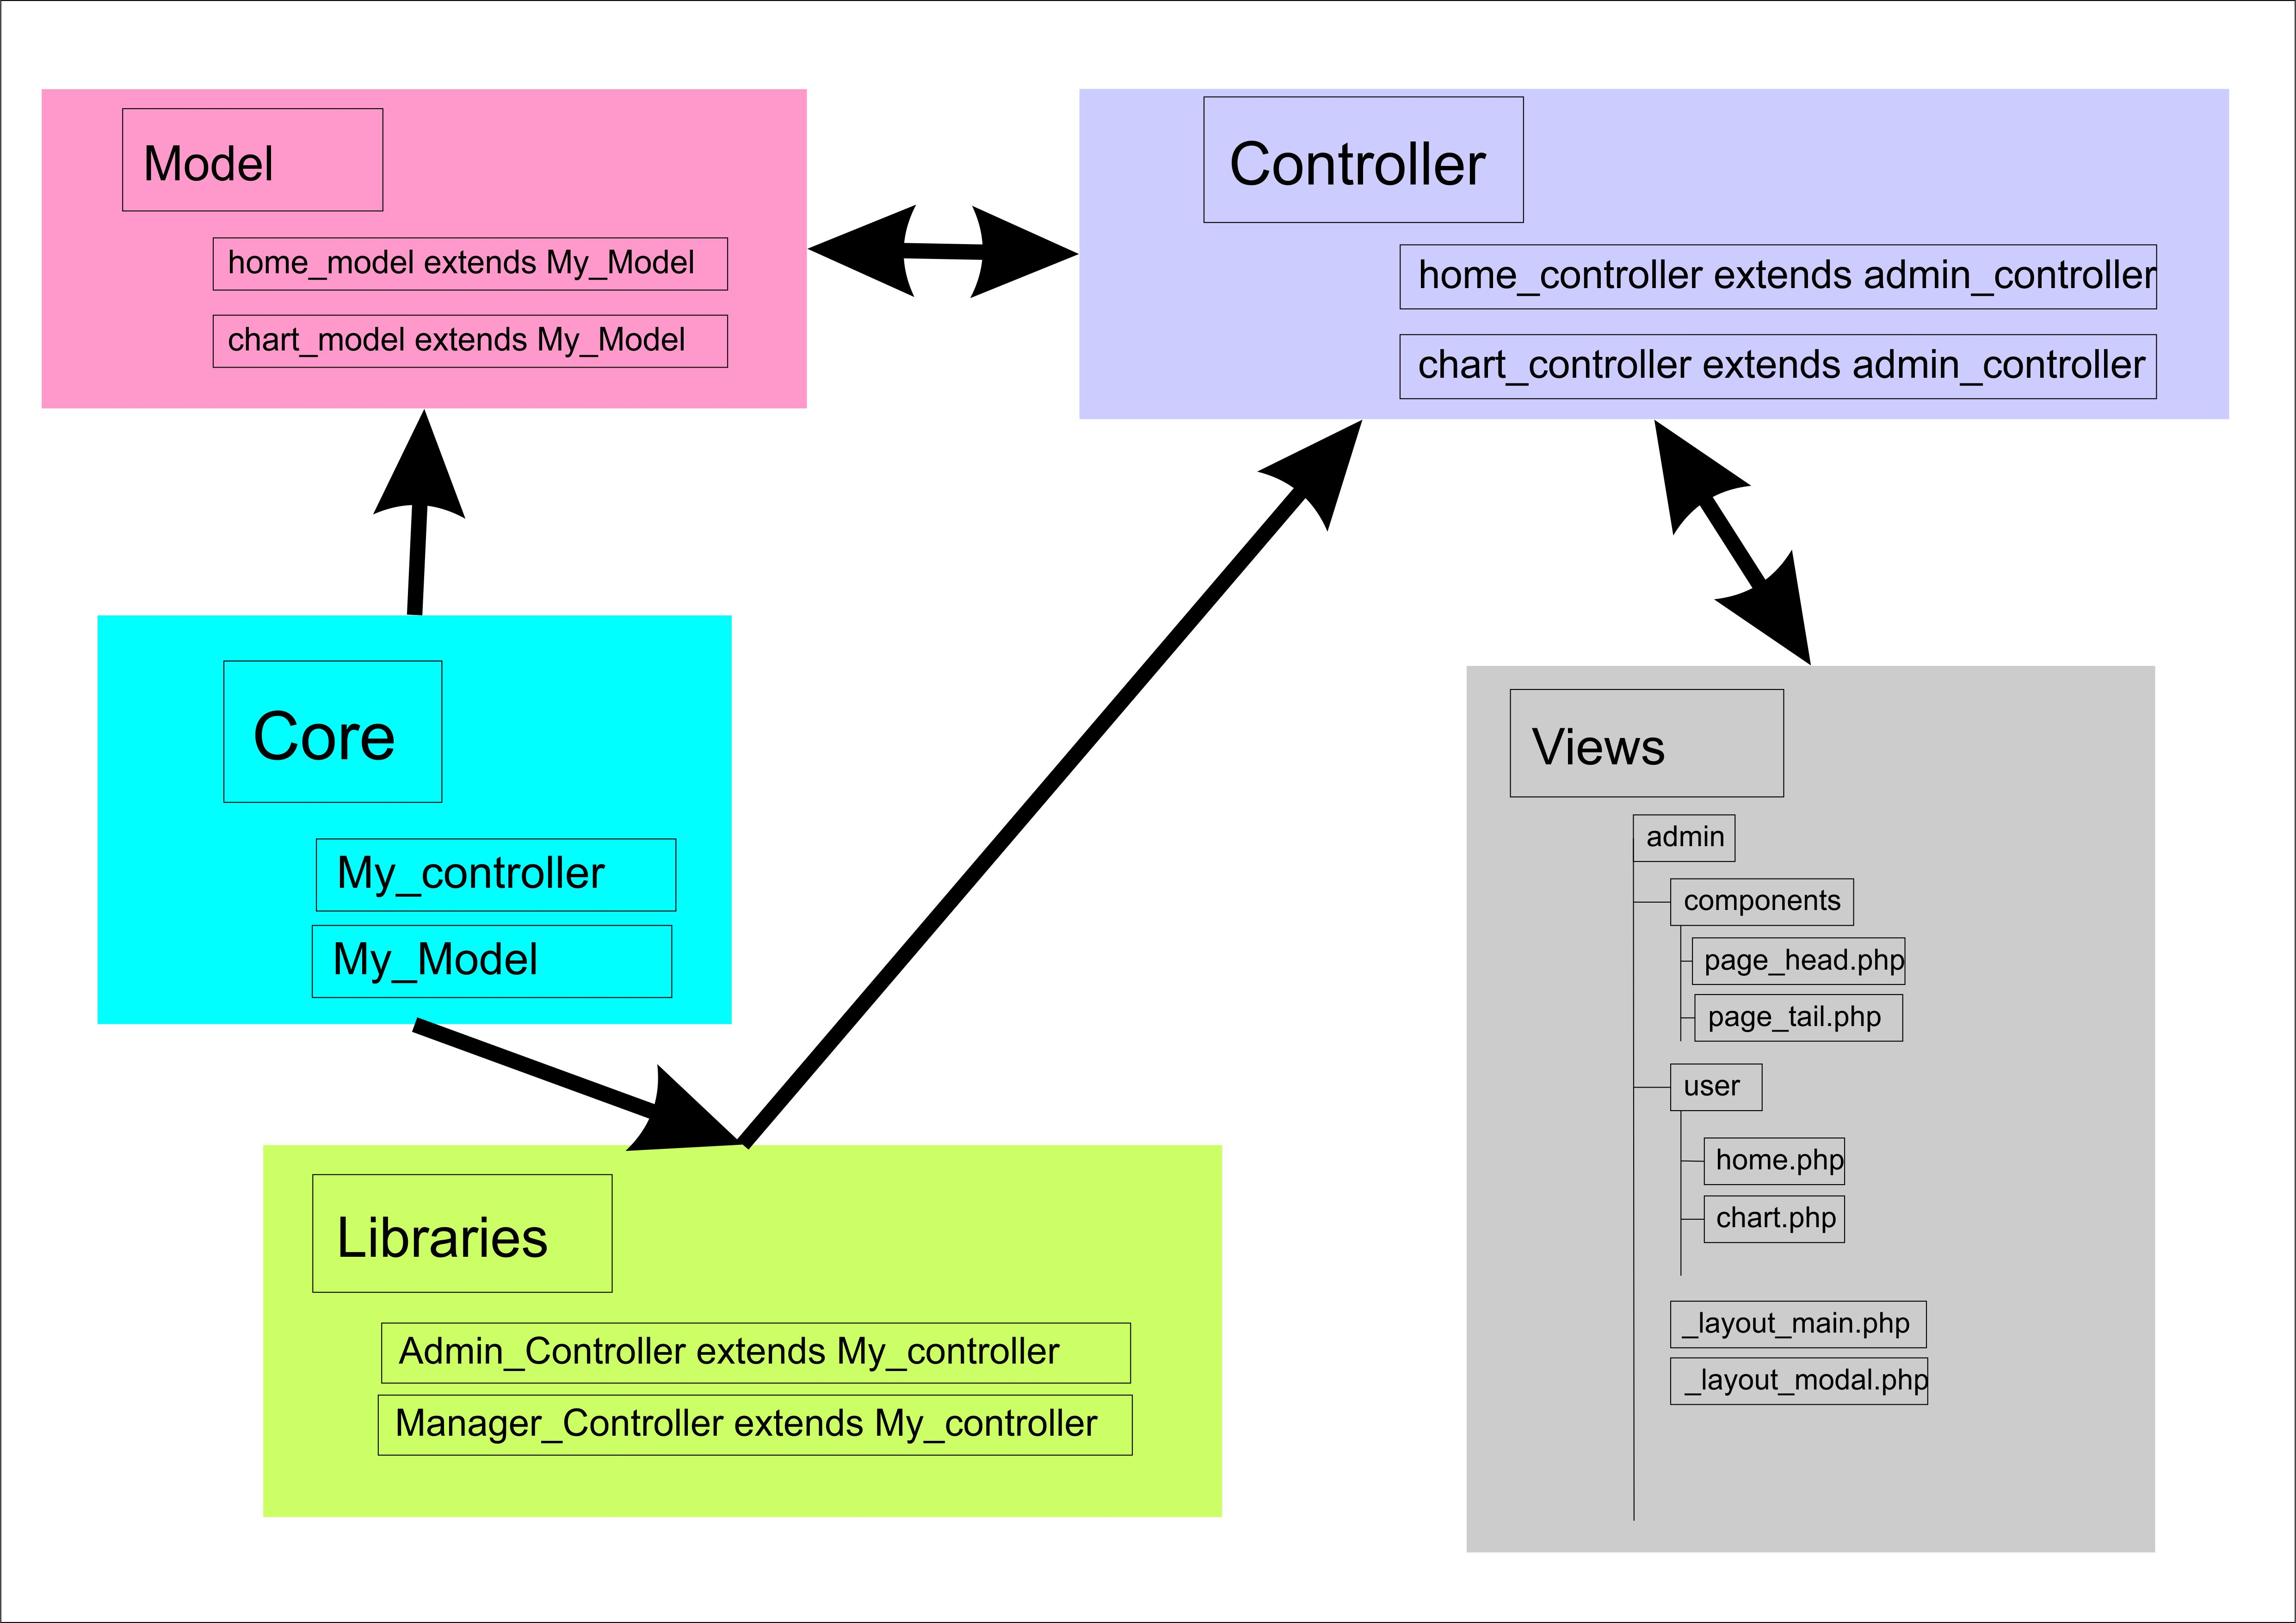

Application/core

In the core folder we put our super classes which all classes must extends like CI_controller class, all the classes in the core folder must extends CI_Controller class

Application/libraries

Libraries folder we separate the user roles, we implement functions relevant to particular user role in this folder. As an example all the admin function implements here relevant to admin, all the functions relevant to manager role implements here as well. The Advantage of this is, when we create a controller in controller folder and if we want give admin behavior to that controller like login, all we need is extends the admin_controller where in library folder. This way we can easily separate the user roles

I have also wrote the insert, delete update functions on My_model class, once you extend your model class with My_model class you can use those functions too. Study the page_m.php class then you’ll understand how it has done.

View

In view folder there is a admin folder, all the views that shown after the login are put inside this folder.

View/admin/component folder contains page header and page tail and view/admin folder contains the _layout_main.php, this is the main layout for our dashboard. This file consist of vertical side bar and horizontal header bar. Page_head.php and page_tail.php are included to _layout_main.php file and in the middle of the _layout_main.php file (line number 435) subview loader. All the subviews are loaded to this place

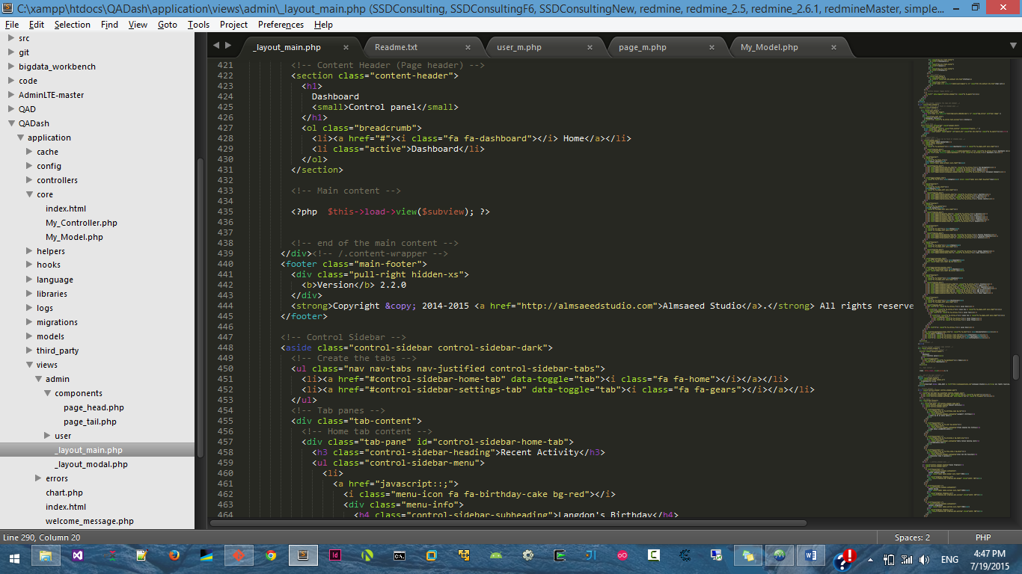

I put all the subviews in view/admin/user folder. As an example home.php is the home page subeview

This home.php subview load via dashboard controller please refer the code for better understanding.

That’s all about structure of the program please fetch the repository frequently because I am continuously editing the project and pull the project before push otherwise deprecated call may be committed to repo which may case issues.